**Military Institute of Science and Technology**

Department of Computer Science and Engineering

Course Title: Data and Tele- Communication Engineering Sessional

Course Code: CSE-318, Cr. Hr: 1.50

Level-3, Term-2

# Experiment No: 12

**Name of the experiment: DSB-SC and SSB Modulator.**

**1. Objectives:**

a. To understand the operation theory of double sideband suppressed carrier (DSB-SC) modulator and single sideband (SSB) modulator.

b. To understand the waveforms and frequency spectrum of DSB-SC and SSB modulators.

c. To design and implement the DSB-SC and SSB modulators.

d. To understand the measurement and adjustment of DSB-SC and SSB modulators.

**2. Theory:**

The operation theory of DSB-SC and SSB Modulator

Figure 5-1 shows the waveforms of the amplitude modulation (AM). Let the audio signal be  and carrier signal be , then the amplitude modulation can be expressed as

 ......................................................... 5.1



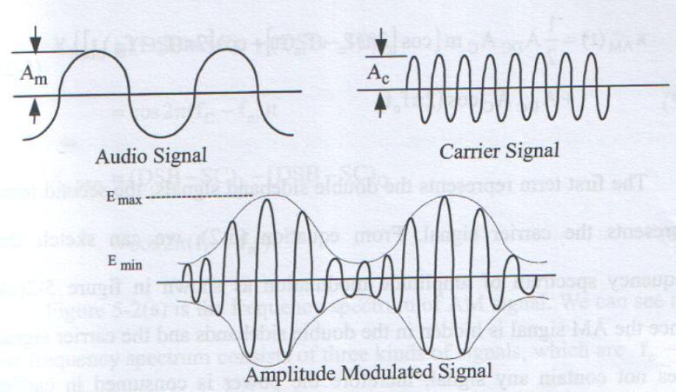

Figure 5-1 Signal waveform of amplitude modulation.

where



DC signal magnitude.

Am : Audio signal amplitude.

Ac : Carrier signal amplitude.

fm : Audio signal frequency.

fc : Carrier signal frequency

m : Modulation index or depth of modulation.

We can rewrite equation (5-1) as

 ....... 5-2

The first term represents the double sideband signals; the second term represents the carrier signal. From equation (5-2), we can sketch the frequency spectrum of amplitude modulation as shown in figure 5-2 (a). Since the AM signal is hidden in the double sidebands and the carrier signal does not contain any signal, therefore the power is consumed in carrier during transmission of amplitude modulation signal. The double sideband suppressed carrier (DSB- SC) modulation means the term  equals to zero, therefore, it can suppress the carrier signal and only left the double sideband. We can use the DSB-SC modulation to obtain the SSB modulation, We utilize two DSB-SC modulators and let the phase difference between the two audio signals and carrier signals be 90 degree, i.e. (DSB-SC)Q and (DSB-SC)I, as shown in equation (5-3) and (5-4).





Equations (5-3) and (5-4) show that both (DSB-SC)Q and (DSB-SC)I signals connect to the adder, the we can obtain USSB or LSSB signal at the output port.



...........................(5-5)



...........................(5-6)

Figure 5-2 (a) is the frequency spectrum of AM signal. We can see that the frequency spectrum consists of three kinds of signals, which are fc-fm, fc and fc+fm. The output voltage of fc is higher than the other two9 signals, therefore, the carrier signal does not contain any signal, and the power is consumed in carrier during transmission of amplitude modulation signal. Figure 5-2 (b) is the frequency spectrum of DSB-SC signals which are fc-fm and fc+fm. These two kinds of signals consists of the transmission signal, therefore, by using this type of modulation, the power will not consume in the carrier. Besides, as a result of the audio signal is hidden in the double sideband, so, the stronger the double sideband signal, the transmission efficiency will be better.

From equation (5-2), we notice that the larger the modulation index, the better the transmission efficiency. Generally, the modulation index is smaller or equal to 1. If the modulation index is greater than 1, we call this situation as over modulation. Figure 5-2 (c) and figure 5-2 (d) are the frequency spectrum of SSB signal. We can see that the frequency spectrum consists of either fc-fm signal or fc+fm signal. Therefore, during transmission, the power consumption of SSB modulation is less than DSB-DC modulation. From the above-mentioned discussion, we know that the sequence of power consumption of the three different types of modulation is AM> DSB –SC>SSB.

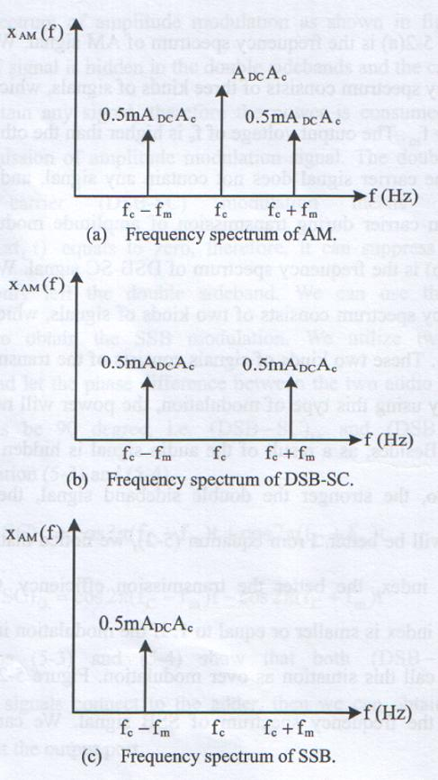

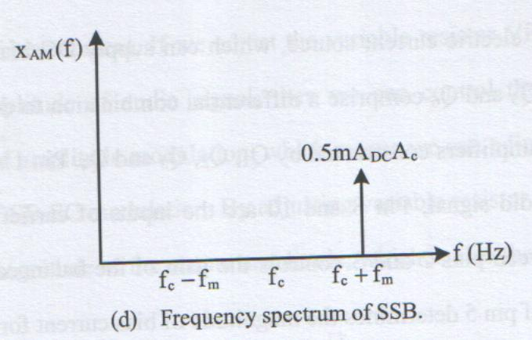

Fig 5-2 Different frequency spectrums of AM modulation.

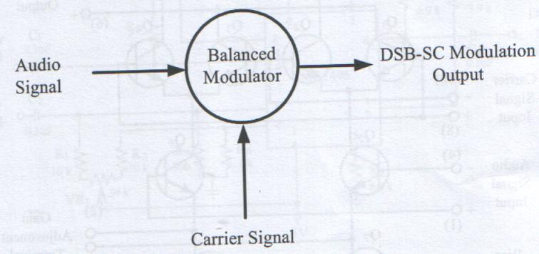

Figure 5-3 Block diagram of DSB-SC modulation.

Fig. 5-3 Block Diagram of DSB-SC modulation

**Implementation if DSB-SC Modulator**

DSB-SC modulation is a kind of AM modulation, therefore, we can utilize the structure of AM modulator to implement the DSB-SC modulator. Figure 5-3 is the block diagram of DSB-SC modulator. We utilize balanced modulator MC1496 to design the DSB-SC modulated signal. Figure 5-4 is the internal circui9t diagram of MC 1496, where D1, R1, R2, R3, Q7 and Q8 comprise an electric source, which can supply DC bias current for Q5 and Q6. Q5 and Q6 comprise a differential combination to drive the dual differential amplifiers constructed by Q1, Q2, Q3 and Q4. Pin 1 and 4 are the inputs of audio signal; Pin 8 and 10 are the inputs of carrier signal. The resistor between pins 2 and 3 controls the gain of the balanced modulator; the resistor of pin 5 determines the magitude of bias current for amplifier.

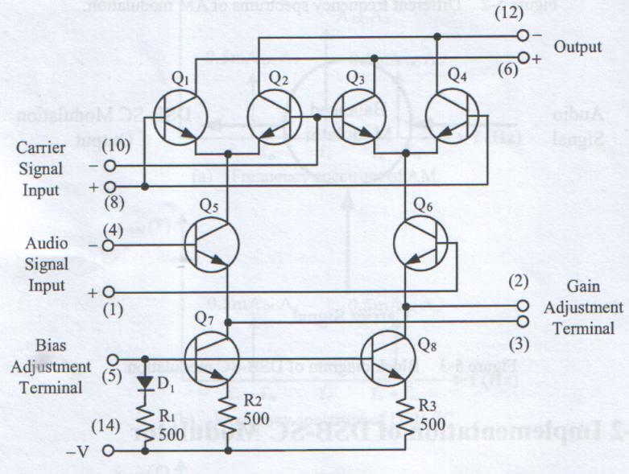

Figure 5-4 Internal circuit diagram of MC1496.

Figure 5-5 is the circuit diagram of AM modulator. We can see that the carrier signal and audio signal belong to single ended input. The carrier signal is inputted from pin 10 and the audio signal is inputted from pin 1. Therefore R8 determine the gain of the whole circuit and R9 determine the magnitude of bias current. If we adjust the variable resistor VR1 or change the input amplitude of audio signal, then we can control the percentage modulation of amplitude modulation, which means we can adjust the output become the DSB-SC modulation. By adjusting variable resistor VR2, we can control the magnitude of the output amplitude, which is also the gain.

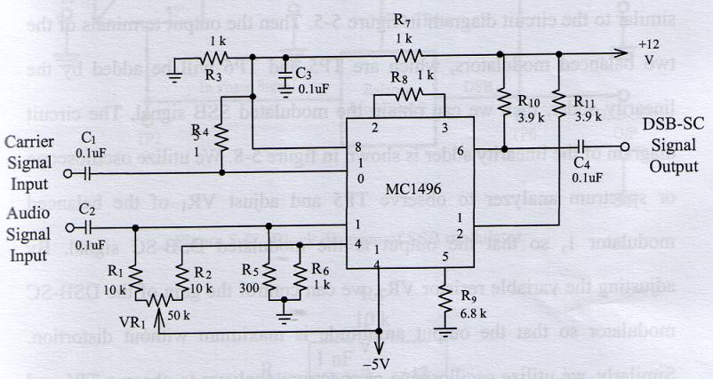

Figure 5-5 Circuit diagram of DSB-SC modulation by utilizing MC1496.

**Implementation of SSB Modulator**

From equations (5-5) and (5-6), we know that the SSB modulator is the combination of two DSB-SC modulators. Figure 5-6 is the block diagram of SSB modulator, where the phase difference of each audio signal and carrier signal of the two DSB-SC modulators is 90 degree (i,e. 90 degree phase difference between TP1 andTP2, and 90 degree phase difference between TP3 and TP4). In figure 5-6, the block if the quadrature phase shift and the phase shift represent the phase shifter. The circuit diagram of phase shifter is shown in figure 5-7. By adjusting the variable resistor, we can control the phase difference between the input and output phase. The circuits of balanced modulator 1 and balanced modulator 2 are similar to the circuit diagram in figure 5-5.

Then the output terminals of the two balanced modulators, which are TP5 and TP6 will be added by the linearity adder, then we can obtain the modulated SSB signal. The circuit diagram of the linearity adder is shown in figure 5-8. We utilize oscilloscope or spectrum analyzer to observe TP5 and adjust VR1 of the balanced modulator 1, so that the output is the modulated DSB-SC signal. By adjusting the variable resistor BR2, we can control the gain of the DSB-SC modulator so that the output amplitude is maximum without distortion. Similarly, we utilize oscilloscope or spectrum analyzer to observe TP6 and adjust VR1 of the balanced modulator 2, so that the output is the modulated DSB-SC signal. By adjusting the variable resistor VR2, we can c0ontrol the gain of the DSB-SC modulator so that the output amplitude is maximum without distortion. Finally, we use the spectrum analyzer to observe the output signal terminal is whether the modulated SSB signal. If the frequency spectrum is not true, we can adjust the variable resistor of the quadrature phase shift.

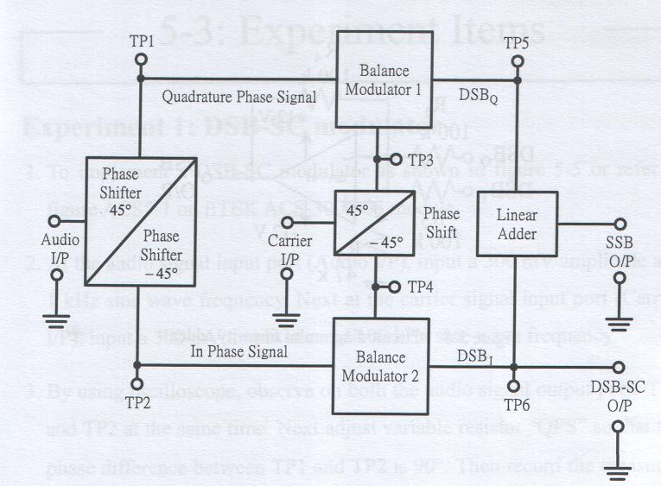

Figure 5-6 Block diagram of SSB modulator.

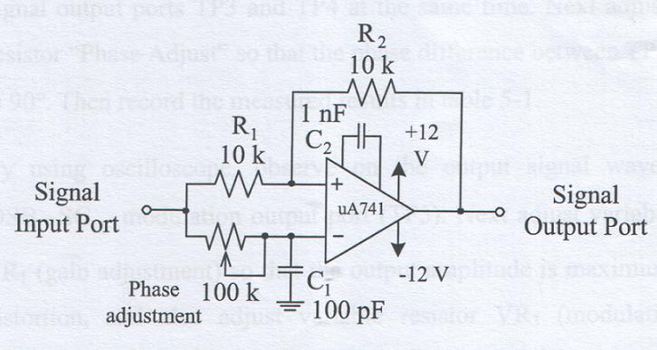

Figure 5-7 Circuit diagram of phase shifter.

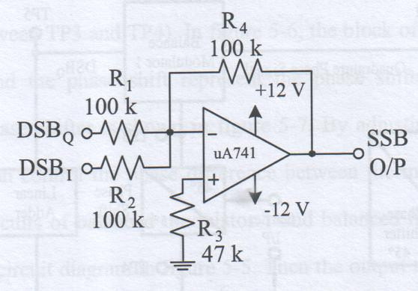

Figure 5-8 Circuit diagram of linearity adder.

**3. Equipments needed**

a. Oscilloscope

b. ETEK module.

c. Signal source (Function generator)

d. Spectrum analyzer

**4. Procedure DSB-SC modulator**

1. To implement a DSB-SC modulator as shown in figure 5-5 or refer to figure ACS5-1 on ETEK ACS-3000-03 module.
2. At the audio signal input port (Audio I/P), input a 300 mV amplitude and 1 KHz sine wave frequency. Next at the carrier signal input port (Carrier I/P) input a 300 mV amplitude and 100KHz sine wave frequency.
3. By using oscilloscope, observe on both the audio signal output ports TP1 and TP2 at the same time. Next adjust variable resistor “QPS” so that the phase difference between TP1 and TP2 is 900. Then record the measured results in table 5-1. By using oscilloscope, observe on both the carrier signal output portsTP3 and TP4 at the same time. Next adjust variable resistor “Phase adjust” so that the phase difference between TP3 and TP4 is 900. Then record the measured results in table 5-1.
4. By using oscilloscope, observe on the output signal waveforms of DSB-SCQ modulation output port (TP5). Next adjust variable resistor VR1(gain adjustment) so that the output amplitude is maximum without distortion, and also adjust variable resistor VR3 (modulation index adjustment) so that the center level of upper peak and lower peak are 0V or the modulation index is 100%. Finally, record the measured results in table 5-2.
5. Change the oscilloscope to spectrum analyzer, observe on the output signal waveforms of TP5 and record the measured results in table 5-2.
6. By using oscilloscope, observe on the output signal waveforms of DSB-SC1 modulation output port (TP6). Next adjust variable resistor VR2 (gain adjustment) so that the output amplitude is maximum without distortion, and also adjust variable resistor VR4 (modulation index adjustment) so that the center level of upper peak and lower peak are 0 V or the modulation index is 100%. Finally, record the measured results in table 5-3.
7. Change the oscilloscope to spectrum analyzer, observe on the output signal waveforms of TP6 and record the measured results in table 5-3.
8. According to the input signals in table 5-4, repeat step 3 and record the measured results in table 5-4.
9. According to the input signals in table 5-4, repeat steps 4 and 5, then record the measured results in table 5-5.
10. According to the input signals in table 5-4, repeat steps 6 and 7, then observe on TP6 and the DSB-SC1 output port (DSB-SC O/P). Finally record the measured results in table 5-6.
11. According to the input signals in table 5-7, repeat step 3 and record the measured results in table 5-7.
12. According to the input signals in table 5-7, repeat steps 4 and 5, then record the measured results in table 5-8.
13. According to the input signals in table 5-7, repeat steps 6 and 7, then observe on TP6 and the DSB-SC1 output port (DSB-SC O/P). Finally, record the measured results in table 5-9.

Table 5-1 Measured results of phase adjustment.

(Audio I/P VP = 300 mV, f = 1 KHz; Carrier I/P VP = 300 mV, f = 100 KHz)

|  |  |
| --- | --- |
| TP1  and  TP2 |  |
| TP3  and  TP4 |  |

Table 5-2 Measured results of modulated DSB-SC signal (TP5).

(Audio I/P VP = 300 mV, f = 1 KHz; Carrier I/P VP = 300 mV, f = 100 KHz)

|  |  |
| --- | --- |
| Oscilloscope |  |
| Spectrum analyzer |  |

Table 5-3 Measured results of modulated DSB-SC signal (TP6).

(Audio I/P VP = 300 mV, f = 1 KHz; Carrier I/P VP = 300 mV, f = 100 KHz)

|  |  |
| --- | --- |
| Oscilloscope |  |
| Spectrum analyzer |  |

Table 5-4 Measured results of phase adjustment.

(Audio I/P VP = 300 mV, f = 1 KHz; Carrier I/P VP = 300 mV, f = 300 KHz)

|  |  |
| --- | --- |
| TP1  and  TP2 |  |
| TP3  and  TP4 |  |

Table 5-5 Measured results of modulated DSB-SC signal (TP6).

(Audio I/P VP = 300 mV, f = 1 KHz; Carrier I/P VP = 300 mV, f = 300 KHz)

|  |  |
| --- | --- |
| Oscilloscope |  |
| Spectrum analyzer |  |

Table 5-6 Measured results of modulated DSB-SC signal (TP6).

(Audio I/P VP = 300 mV, f = 1 KHz; Carrier I/P VP = 300 mV, f = 300 KHz)

|  |  |
| --- | --- |
| Oscilloscope |  |
| Spectrum analyzer |  |

Table 5-7 Measured results of phase adjustment.

(Audio I/P VP = 300 mV, f = 1 KHz; Carrier I/P VP = 300 mV, f = 500 KHz)

|  |  |
| --- | --- |
| TP1  and  TP2 |  |
| TP3  and  TP4 |  |

Table 5-8 Measured results of modulated DSB-SC signal (TP5).

(Audio I/P VP = 500 mV, f = 1 KHz; Carrier I/P VP = 500 mV, f = 500 KHz)

|  |  |
| --- | --- |
| Oscilloscope |  |
| Spectrum analyzer |  |

Table 5-9 Measured results of modulated DSB-SC signal (TP6).

(Audio I/P VP = 500 mV, f = 1 KHz; Carrier I/P VP = 500 mV, f = 500 KHz)

|  |  |
| --- | --- |
| Oscilloscope |  |
| Spectrum analyzer |  |

**5. Procedure - SSB Modulator:**

1. To implement a SSB modulator as shown in figure 5-6 or refer to figure ACS5-1 on ETEK ACS-3000-03 module.
2. At the audio signal input port (Audio I/P), input a 300 mV amplitude and 1 KHz sine wave frequency. Next at the carrier signal input port (Carrier input), input a 300mV amplitude and 200 KHz sine wave frequency.
3. By using oscilloscope, observe on both the audio signal output ports TP1 and TP2 at the same time. Next adjust variable resistor “QPS” so that the phase difference between TP1 and TP2 is 900. Then record the measured results in table 5-10. By using oscilloscope, observe on both the carrier signal output ports TP3 and TP4 at the same time. Next adjust variable resistor “Phase adjust” so that the phase difference between TP3 and TP4 is 900. Then record the measured results in table 5-10.
4. By using oscilloscope, observe on the output signal waveforms of DSB-SCQ modulation output port (TP5). Next adjust variable resistor VR1(gain adjustment) so that the output amplitude is maximum without distortion, and also adjust variable resistor VR3 (modulation index adjustment) so that the centre level of upper peak and lower peak are 0 V or the modulation index is 100%. Finally, record the measured results in table 5-11.
5. Change the oscilloscope to spectrum analyzer, observe on the output signal waveforms of TP5 and record the measured results in table 5-11.
6. By using oscilloscope, observe on the output signal waveforms of DSB-SC1 modulation output port (TP6). Next adjust variable resistor VR2 (gain adjustment) so that the output amplitude is maximum without distortion, and also adjust variable resistor VR4 (modulation index adjustment) so that the center level of upper peak and lower peak are 0 V or the modulation index is 100%. Finally, record the measured results in table 5-12.
7. Change the oscilloscope to spectrum analyzer, observe on the output signal waveforms of TP6 and record the measured results in table 5-12.
8. By using oscilloscope, observe on the output signal waveforms of SSB modulation output port (SSB O/P), then record the measured results in table 5-13.
9. By using spectrum analyzer, observe on the output signal waveforms of SSB modulation output port (SSB O/P), then record the measured results in table 5-13.

Table 5-10 Measured results of phase adjustment.

(Audio I/P VP = 300 mV, f = 1 KHz; Carrier I/P VP = 300 mV, f = 200 KHz)

|  |  |
| --- | --- |
| TP1  and  TP2 |  |
| TP3  and  TP4 |  |

Table 5-11 Measured results of modulated DSB-SC signal (TP5).

(Audio I/P VP = 300 mV, f = 1 KHz; Carrier I/P VP = 300 mV, f = 200 KHz)

|  |  |
| --- | --- |
| Oscilloscope |  |
| Spectrum analyzer |  |

Table 5-12 Measured results of modulated DSB-SC signal (TP6).

(Audio I/P VP = 300 mV, f = 1 KHz; Carrier I/P VP = 300 mV, f = 200 KHz)

|  |  |
| --- | --- |
| Oscilloscope |  |
| Spectrum analyzer |  |

Table 5-13 Measured results of SSB modulation signal (SSB O/P).

(Audio I/P VP = 300 mV, f = 1 KHz; Carrier I/P VP = 300 mV, f = 200 KHz)

|  |  |
| --- | --- |
| Oscilloscope |  |
| Spectrum analyzer |  |

**6. Problem discussion**

1. Explain the definitions of DSB-SC modulation and SSB modulation.
2. Explain the reasons that why the audio signal and the carrier signal need phase shifter to produce the orthogonal signal.
3. Explain the advantages and disadvantages of DSB-SC modulation and SSB modulation.
4. Explain the output signal waveform of SSB O/P, if the phase difference of DSB-SCQ and DSB-SC1 is same. (Refer to the measured results from oscilloscope and spectrum analyzer in table 5-13).